# Homework for 17 Beetroot lesson “API Testing”

## Beet Sprout

### В Google docs створи 5 тест-кейсів для функціонального тестування сайту <https://automoto.ua/uk/> (5 найбільш пріоритетних тестів). Посилання на документ додай до ЛМС

1. **Automoto-1**

**Summary:** Checking the correct functionality of car searching on the main website page

**Priority:** 1

**Test Case Objective:** Make sure that the user can find cars by various criteria using search engine filters

**STR:**

1. Open the homepage of website;
2. Check for correct functionality of criterias in appropriate filter fields;
3. Click “Search”.

**Expected result:** website’s car search engine displays a list of cars that meet the specified criteria.

1. **Automoto-2**

**Summary:** Changing the website language to UA from EN

**Priority:** 4

**Test Case Objective:** Verify that users can change website language using the buttons in the right top section of webpage

**STR:**

1. Go to the homepage of website;
2. Ensure the website language is choosed to EN;
3. Change the language to the UA;
4. Notice the differences in language have applied.

**Expected result:** The website language has changed to UA.

1. **Automoto-3**

**Summary:** Choosing the “All Second-used Cars” menu section for the main menu

**Priority:** 3

**Test Case Objective:** To verify that the “All Second-used Cars” menu section is opening the appropriate page.

**STR:**

1. Go to the homepage of website;
2. Hover the cursor on the “Second-used Car” menu section;
3. Choose the “All Second-used Cars” link in the dropdown menu;
4. Notice the link redirecting to the page with all the cars that were second-used.

**Expected result:** The “All Second-used Cars” menu section opens the page with all the second-used cars announcements.

1. **Automoto-4**

**Summary:** Opening the “Contacts” link that located in the webpage footer

**Priority:** 2

**Test Case Objective:** Ensure that link redirects users to the “Contacts” page of the website.

**STR:**

1. Go to the homepage of website;
2. Scroll down to the footer of the webpage;
3. Click on the “Contacts” button;
4. Notice the redirection to the page with contacts.

**Expected result:** The page with contact information is opened after clicking on the “Contacts” button in the webpage footer.

1. **Automoto-5**

**Summary:** Opening the “Instagram” link that located in the webpage footer

**Priority:** 5

**Test Case Objective:** Ensure that link redirects users to the “Instagram” page of the website.

**STR:**

1. Go to the homepage of website;
2. Scroll down to the footer of the webpage;
3. Click on the button with “Instagram” icon;
4. Notice the redirection to the Instagram page.

**Expected result:** The Instagram page is opened after clicking on the button with the “Instagram” icon in the webpage footer.

### За допомогою <https://reqbin.com/> протестуй методи API [Reqres](https://reqres.in/)

| **Method** | **Endpoint** | **Params | Body** | **What it does?** | **Status Code** | **Test Case Status** |
| --- | --- | --- | --- | --- | --- |
| ***GET*** | /api/users | - | Lists all the users of the first page, with default limit of records - 6 per page | 200 | **Passed** |
| ?page=1 | Lists all the users of the second page, with default limit of records - 6 per page | 200 | **Passed** |
| ?page=2&per_page=2 | Lists all the users of the second page, with specified limit of records - 2 per page | 200 | **Passed** |
| ?i=10 | Negative test case with specifying non-existent "i" parameter | 200 | **Passed** |
| ***GET*** | /api/users/1 | - | Details about the user with id "1" | 200 | **Passed** |
| /api/users/0 | - | Negative test for checking info about non-existent user | 404 | **Passed** |
| ***POST*** | /api/users | {  "name": "Testname",  "job": "Testjob"  } | Creates new user with name "Testname", job "Testjob" and random id | 201 | **Passed** |
| {  "name": 0,  "job": "Testjob"  } | Negative test for checking datatype corresponding | 201 | **Failed¹** |
| {  "name": 0,  "job": 0  } | 201 | **Failed¹** |
| ***PUT*** | /api/users/7 | {  "name": "Michael",  "job": "123"  } | Updates an existing user | 200 | **Passed** |
| /api/users/1 | {  "name": 1,  "job": "123"  } | Negative test for checking datatype corresponding | 200 | **Failed¹** |
| {  "name": 1,  "job": 1  } | 200 | **Failed¹** |
| ***PATCH*** | /api/users/5 | {  "name": "Michael",  "job": "123"  } | Updates an existing user | 200 | **Passed** |
| {  "name":  {  "name": "123",  "job": "111"  },  "job":  {  "name": "123",  "job": "111"  }  } | Negative test for checking datatype corresponding | 200 | **Failed¹** |
| ***DELETE*** | /api/users/5 | - | Deleting existing user | 204 | **Passed** |
| /api/users/0 | Negative test for checking deletion non-existent user | 204 | **Failed²** |
| ***POST*** | /api/register | {  "email": "eve.holt@reqres.in",  "password": "pistol"  } | Registering new user | 200 | **Passed** |
| ***POST*** | /api/login | {  "email": "eve.holt@reqres.in",  "password": "cityslicka"  } | Login as registered user | 200 | **Passed** |

1. Для методів POST (на створення), PUT та PATCH (оновлення), перевірка типів даних некоректна - для вказання імені та роботи користувача можна вказати non-string значення.

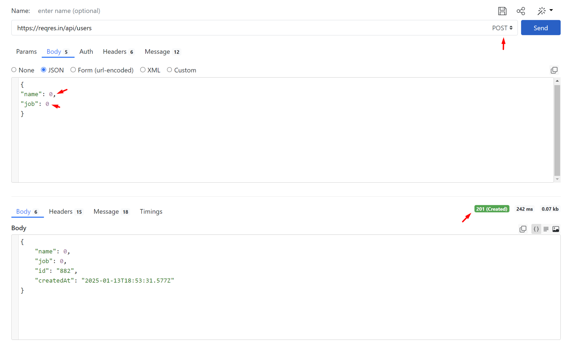

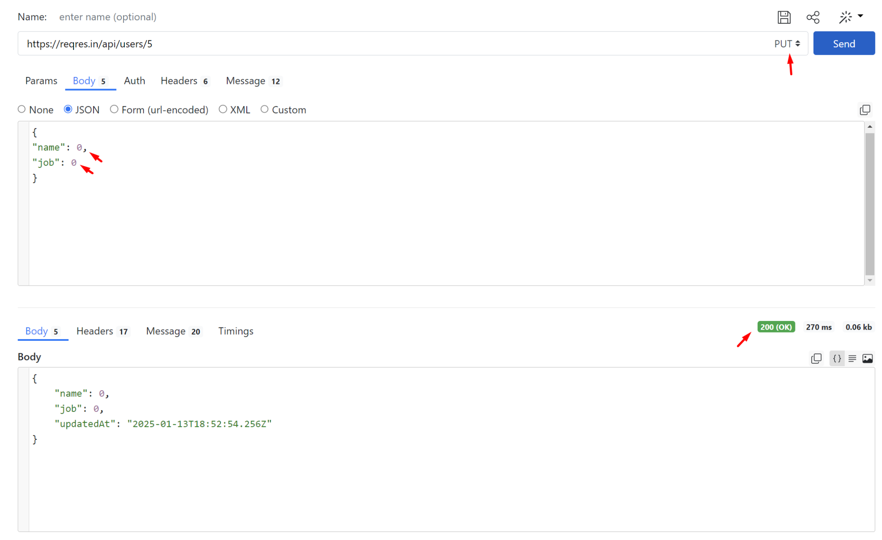

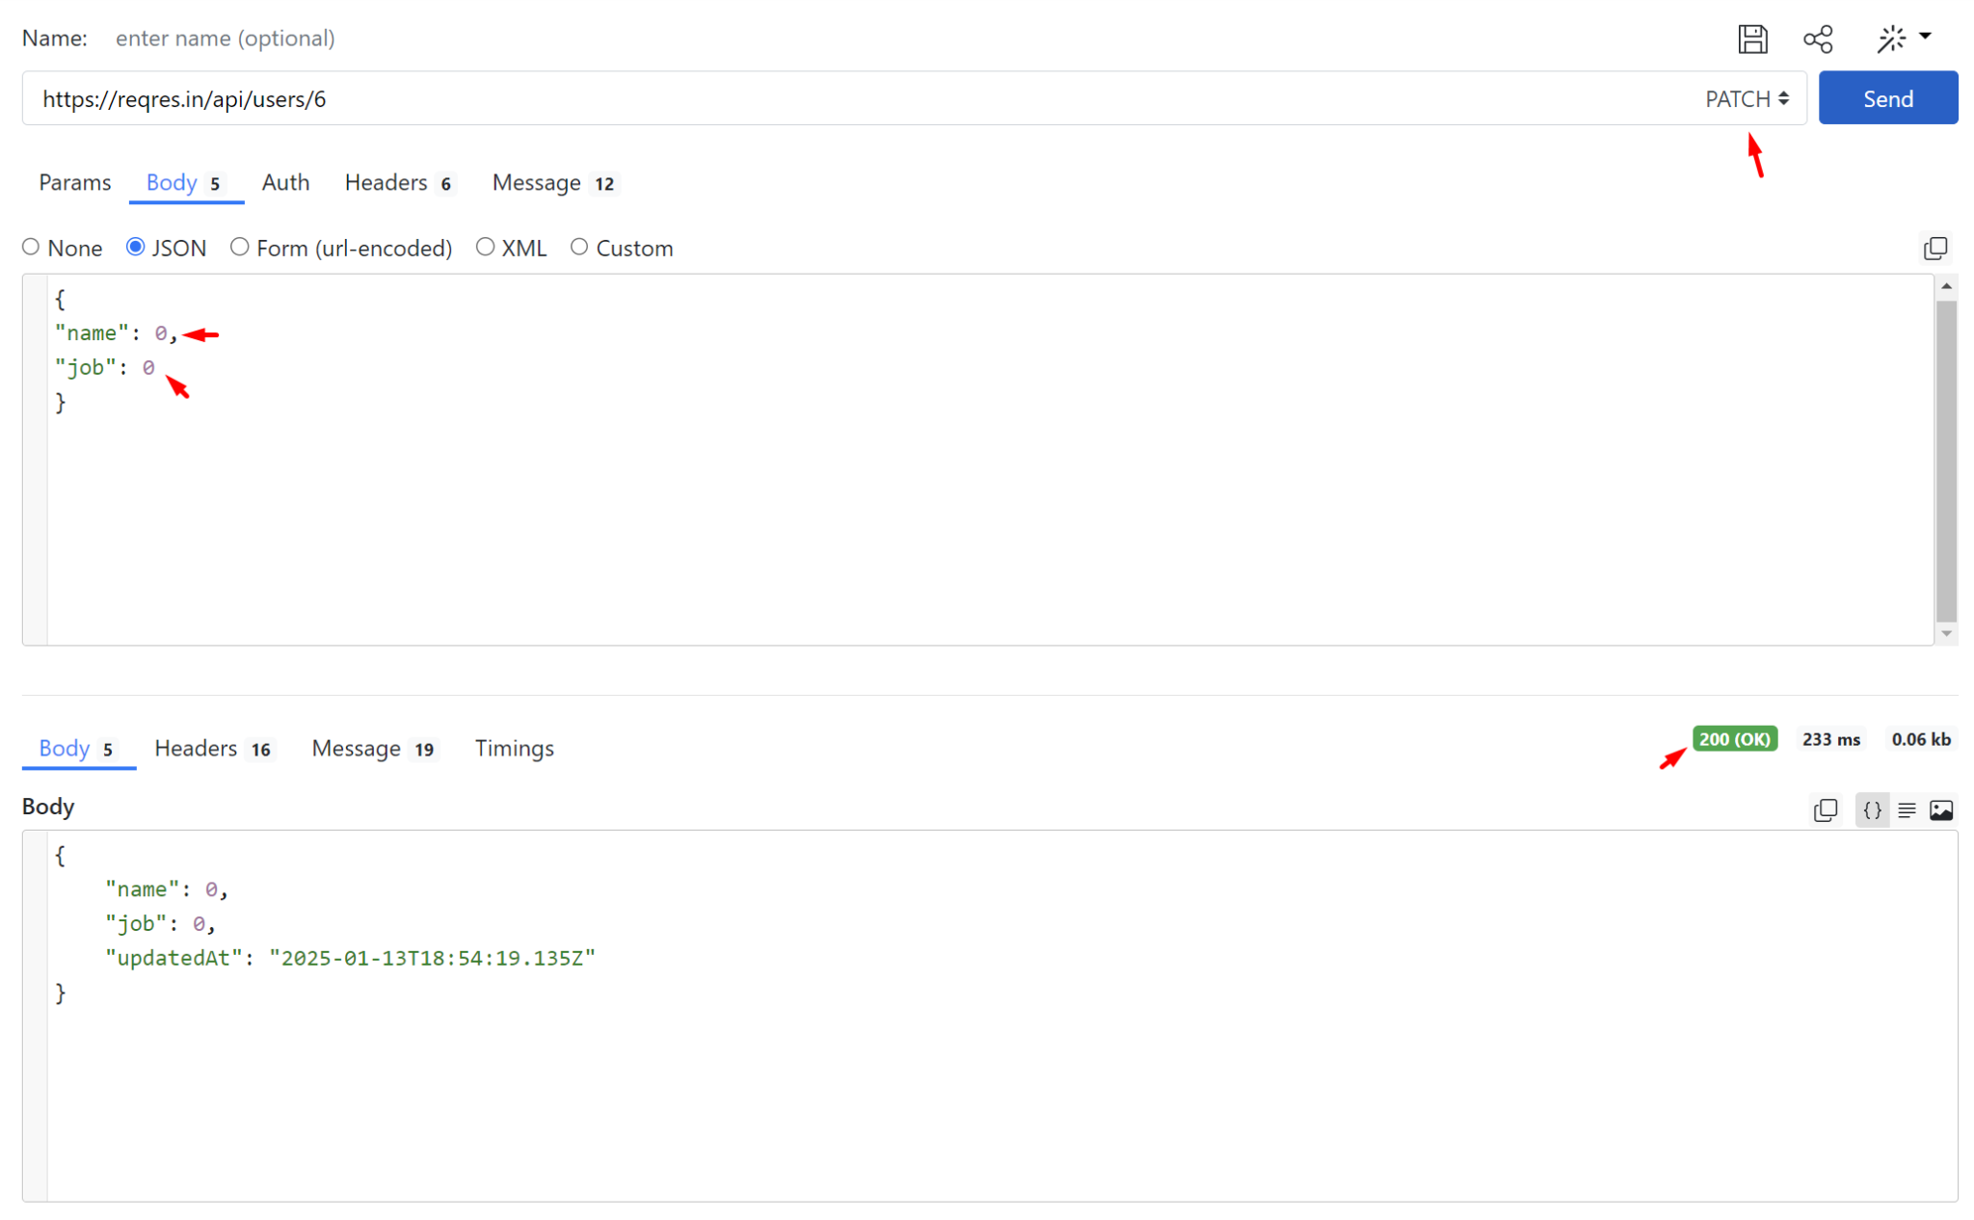

1. Для методу DELETE (на видалення), відсутня перевірка на наявність запису в базі даних.

